Spring Framework

It is a framework that manages your objects and connects them automatically.

Need of Spring :-

Without Spring :-
Engine engine=new Engine();
Car car=new Car(engine);

You create everything manually , code become tightly coupled , hard to change later

With spring :-
@Autowired
Engine engine;( creates objects, spring connect them , code become flexible)

Core Concepts:-
- IoC :-- Inversion of control

Normally:- You create objects.
Spring:- Spring create objects.

- DI:- Dependency Injection :--- When one class needs another class.

Class Car{
Engine engine;
}

Bean:- Any object managed by Spring =Bean

@Component
class Engine{}

Spring Container:- This is the engine of Spring
Types:-
- BeanFactory
- ApplicationContext

What does container do :-
Creates objects-- injects dependencies-- Mananges lifecycle.

Flow of the Spring :-

- You write classes
- Add annotations(@component)
- Spring scans classes
- Spring creates objects (Beans)
- Spring injects dependencies
- Apllication runs .

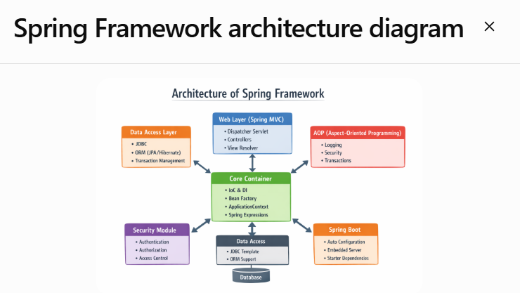

Spring Framework
│
├── Core Container (CENTER / HEART ❤️)
│ ├── IoC & DI
│ ├── BeanFactory
│ ├── ApplicationContext
│ └── Spring Expressions
│
├── Web Layer (Spring MVC)
│ ├── DispatcherServlet
│ ├── Controllers
│ └── View Resolver
│
├── Data Access Layer
│ ├── JDBC
│ ├── ORM (JPA/Hibernate)
│ └── Transaction Management
│
├── AOP
│ ├── Logging
│ ├── Security
│ └── Transactions
│
├── Security Module
│ ├── Authentication
│ ├── Authorization
│ └── Access Control
│
├── Spring Boot
│ ├── Auto Configuration
│ ├── Embedded Server
│ └── Starter Dependencies
│
└── Database (bottom)

IOC container:-

IoC (Inversion of Control)
│
├── Container (Brain)
│ ├── Create Beans
│ ├── Inject Dependencies
│ └── Manage Lifecycle
│
├── Beans (Objects):- contains the application logic
│
├── Configuration (Instructions):- it tells spring what to create and how to create . (Annotations (@component,@Bean), XML , Java Config .
│
├── DI (Injection mechanism)
│
└── Lifecycle Management:- creation , initialization , destruction .

Types of the Ioc Containers:-

Bean Factory:-
BeanFactory is the simplest container that creates beans only when required (lazy loading).

Lazy loading is a concept in Spring Framework (and many other technologies) where an object (bean) is created only when it is actually needed, not at application startup.

BeanFactory factory = new XmlBeanFactory(new ClassPathResource("config.xml"));
Car car = factory.getBean("car", Car.class);

ApplicationContext:-

ApplicationContext is an advanced container that creates and manages beans with extra features.

🔹 Key Features:
✔ Eager Initialization (by default)
✔ AOP support
✔ Event handling
✔ Internationalization
✔ Auto scanning (@Component)

Eager Initialization (by default)
👉 ApplicationContext
- Creates all beans at startup
- So everything is ready to use
👉 BeanFactory
- Creates bean only when you call getBean() (lazy)
Simple example:
- ApplicationContext → “Cook all food before guests arrive” 🍲
- BeanFactory → “Cook only when someone orders” 🍔
✅ Benefit: Errors are found early + faster access later

2️⃣ AOP Support (Aspect-Oriented Programming)
👉 ApplicationContext supports AOP (like logging, security, transactions)
Simple meaning:
You can add extra behavior without changing your main code
Example:
- Automatically log every method call
- Add security checks
BeanFactory ❌ does NOT support this easily

3️⃣ Event Handling
👉 ApplicationContext can handle events
Simple meaning:
One object can notify others when something happens
Example:
- “User registered” event
- “Order placed” event
Other parts of app can listen and react
BeanFactory ❌ No built-in event system

4️⃣ Internationalization (i18n)
👉 ApplicationContext supports multiple languages 🌍
Example:
- English → “Welcome”
- Hindi → “स्वागत है”
You can show messages based on user language
BeanFactory ❌ No support

5️⃣ Auto Scanning (@Component)
👉 ApplicationContext can automatically find classes
@Component
class Student { }
Simple meaning:
No need to manually define beans in XML
Spring will scan and create beans automatically
BeanFactory ❌ Manual work needed

Working:
Application starts
↓
ApplicationContext created
↓
All Beans created immediately ❗
↓
Dependencies injected
↓
Ready to use

ApplicationContext context =
new ClassPathXmlApplicationContext("config.xml");
Car car = context.getBean("car", Car.class);

TYPES OF ApplicationContext
👉 There are multiple implementations:

🔹 1. ClassPathXmlApplicationContext
- Loads XML from classpath

Loads XML from classpath” is a very common phrase in frameworks like Spring Framework, and it simply means:
👉 Simple Meaning
It means:
The application is reading an XML file that is stored inside the classpath of your project.

🔹 What is Classpath?
Classpath is a location where Java looks for files and classes.
It usually includes:
- src/main/resources
- src
- target/classes
- JAR files
So anything placed in these folders can be accessed by Java.

Spring WebLayer (Spring MVC):-

The Web Layer (Spring MVC) is responsible for:
Handling user requests and sending responses back.

COMPLETE REQUEST FLOW (VERY IMPORTANT)
User (Browser)
↓
DispatcherServlet (Front Controller)
↓
Controller
↓
Service (Business Logic)
↓
Repository (Database)
↓
Database
↑
Response → User

MAIN COMPONENTS OF SPRING WEB LAYER

1. DispatcherServlet (HEART ❤️)
👉 Central controller of Spring MVC

🔹 Responsibilities:
✔ Receives all requests
✔ Decides which controller to call
✔ Sends response back

What is a controller ?

  - It is a class
  - In the Spring Framework, a Controller is a class that handles user requests and returns responses.
In Web Application Flow
- User sends request (URL)
- Controller receives it
- Calls service/business logic
- Returns response (data/page)

🔹 Example in Spring
import org.springframework.stereotype.Controller;
import org.springframework.web.bind.annotation.RequestMapping;
@Controller
public class HomeController {
@RequestMapping("/home")
public String home() {
return "home"; // returns view/page
}
}

🔹 What Controller Does
✔ Handles HTTP requests (GET, POST, etc.)
✔ Processes user input
✔ Calls service layer
✔ Returns response (HTML, JSON, etc.)

🔹 Types of Controllers in Spring
1️⃣ @Controller
- Returns web pages (views)
2️⃣ @RestController
- Returns data (JSON/XML)

🔹 Example of @RestController
@RestController
public class MyController {
@GetMapping("/data")
public String getData() {
return "Hello World";
}
}

2. FileSystemXmlApplicationContext:- class in the spring framework use to load an XML configuration file system instead of the class path .
- Loads XML from file system
- It loads a Spring XML configuration file using a full file path (like from your disk), not from inside the project classpath.

🔹 3. AnnotationConfigApplicationContext ⭐
- Uses Java config & annotations
ApplicationContext context =
new AnnotationConfigApplicationContext(Config.class);

🔹 4. WebApplicationContext
- Used in web applications

Dependency Injection :-
Dependency Injection means: providing required objects (dependencies) from outside instead of creating them inside the class.

🎯 ONE-LINE
👉 DI = Don’t create objects, let Spring provide them

🔴 PROBLEM (WITHOUT DI)
class Car {
Engine engine = new Engine(); ❌
}
❌ Issues:
- Tight coupling
- Hard to test
- Hard to change

🟢 SOLUTION (WITH DI)
@Component
class Car {
@Autowired
Engine engine; ✅
}
👉 Spring injects Engine into Car

TYPES OF DEPENDENCY INJECTION

🔵 1. CONSTRUCTOR INJECTION ⭐ (BEST)
@Component
class Car {
Engine engine;
public Car(Engine engine) {
this.engine = engine;
}
}

✅ Features:
✔ Mandatory dependency
✔ Object always complete
✔ Best for testing
✔ Recommended in interviews

🧠 Real-life:
Chef gets all ingredients before cooking

🟡 2. SETTER INJECTION
@Component
class Car {
Engine engine;
@Autowired
public void setEngine(Engine engine) {
this.engine = engine;
}
}

✅ Features:
✔ Optional dependency
✔ Can change later

🧠 Real-life:
Chef can add ingredients later

Spring Expression :-

SpEL is a way to write expressions inside Spring configuration to dynamically get or calculate values.
👉 In short:
- It lets you write logic inside configuration (XML or annotations)

Example:-
<bean id="student" class="com.example.Student">
<property name="age" value="#{20 + 5}"/>
</bean>
What is @SpringBootApplication?
This is a very important annotation in Spring Boot.
👉 It is actually a combination of 3 annotations:
✅ 1. @Configuration
- Tells Spring:
👉 “This class contains configuration (like XML earlier)”

✅ 2. @EnableAutoConfiguration
- This is the magic of Spring Boot ✨
- It automatically configures things like:
  - Database connection
  - Tomcat server
  - Spring MVC
👉 Example:
- If MySQL dependency is present → Spring auto configures datasource

✅ 3. @ComponentScan
- Tells Spring:
👉 “Scan this package and sub-packages for components”
Components include:
- @Controller
- @Service
- @Repository
- @Component

🔷 3. What does main() method do?
public static void main(String[] args)
👉 This is standard Java entry point.

🔷 4. What is SpringApplication.run(...)?
SpringApplication.run(SpringBootProductApplication.class, args);
This line starts the entire Spring Boot application 🚀
Internally it does:
- Creates Spring container (IOC container)
- Scans components
- Applies auto-configuration
- Starts embedded server (like Tomcat)
- Runs your application

🔷 5. What happens when you run this?
When you run this class:
👉 Spring Boot will:
- Start embedded Tomcat server
- Create all beans
- Connect to DB (if configured)
- Expose APIs (if controller exists)

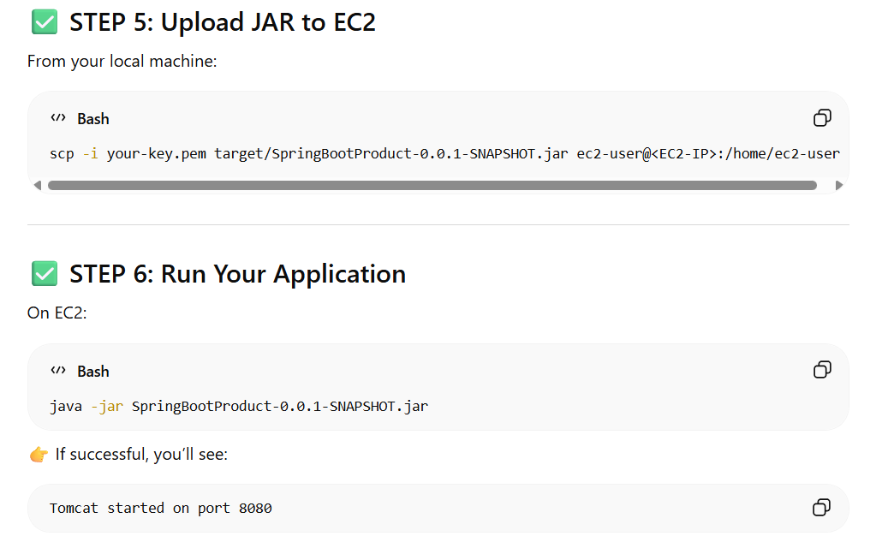
STEP-BY-STEP DEPLOYMENT

✅ STEP 1: Update application.properties (VERY IMPORTANT)
Put your RDS details:
spring.datasource.url=jdbc:mysql://<RDS-ENDPOINT>:3306/productdb
spring.datasource.username=admin
spring.datasource.password=YourPassword
spring.jpa.hibernate.ddl-auto=update
spring.jpa.show-sql=true
server.port=8080

✅ STEP 2: Build Your Project (On Your Local Machine)
In STS or terminal:
mvn clean package
👉 You will get:
target/SpringBootProduct-0.0.1-SNAPSHOT.jar

✅ STEP 3: Connect to EC2

✅ STEP 4: Install Java (Amazon Linux 2023)
sudo dnf update -y
sudo dnf install java-17-amazon-corretto -y
Check:
java -version

✅ STEP 5: Upload JAR to EC2
From your local machine:
scp -i C:/Users/hp/Downloads/spring-ec2key.pem target/SpringBootProduct-0.0.1-SNAPSHOT.jar ec2-user@18.207.96.45:/home/ec2-user

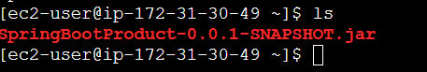

✅ STEP 6: Run Your Application
On EC2:
java -jar SpringBootProduct-0.0.1-SNAPSHOT.jar
👉 If successful, you’ll see:
Tomcat started on port 8080
To run the practical\
:
1) Start EC2 --> connect --> terminal opens
2) in terminal --> java -jar SpringBootProduct-0.0.1-SNAPSHOT.jar
3) If successful, you’ll see --> Tomcat started on port 8080
4) Open terminal below go to Downloads folder
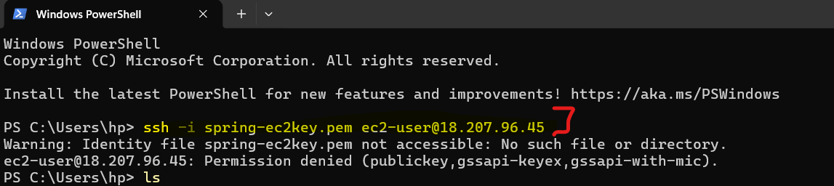
(1) PS C:\Users\hp\Downloads> ssh -i spring-ec2key.pem ec2-user@18.207.96.45
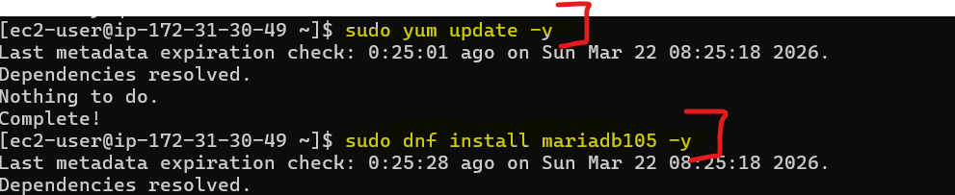
(2) [ec2-user@ip-172-31-30-49 ~]$ sudo yum update -y
(3) [ec2-user@ip-172-31-30-49 ~]$ sudo dnf install mariadb105 -y
(4) [ec2-user@ip-172-31-30-49 ~]$ mysql -h productdb.c3ooe4ow08on.us-east-1.rds.amazonaws.com -u admin -p
Enter password: root1234
Welcome to the MariaDB monitor. Commands end with ; or \g.
